|  |  |
| --- | --- |
| Course Name | ITD 2343 – Object Oriented Programming with C# |
| Instructor | Mark L. Pranger |
| Student Name | Cristhian Carcamo |
| Due date | 2/26/2025 |
| Grade | <grade earned here> |
| Grading Comments | <instructor comments here> |

1. Plus Operator

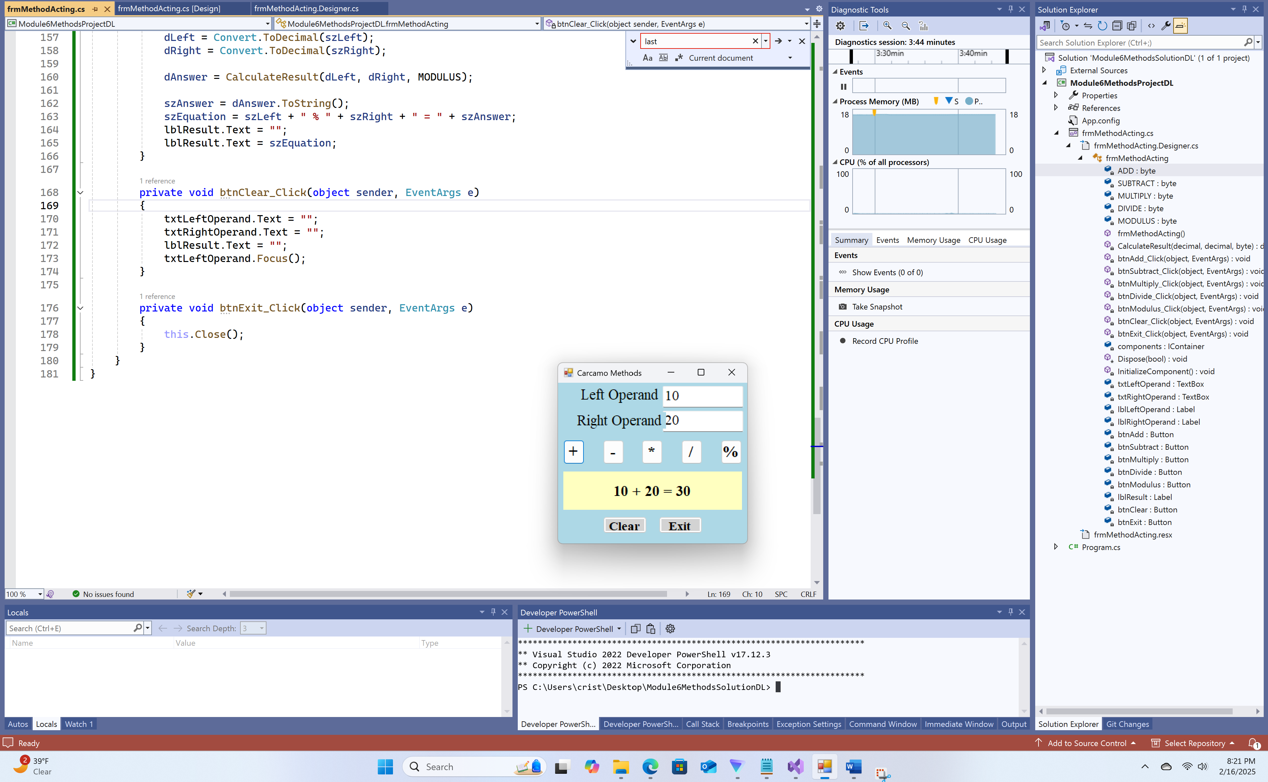

1. Minus Operator

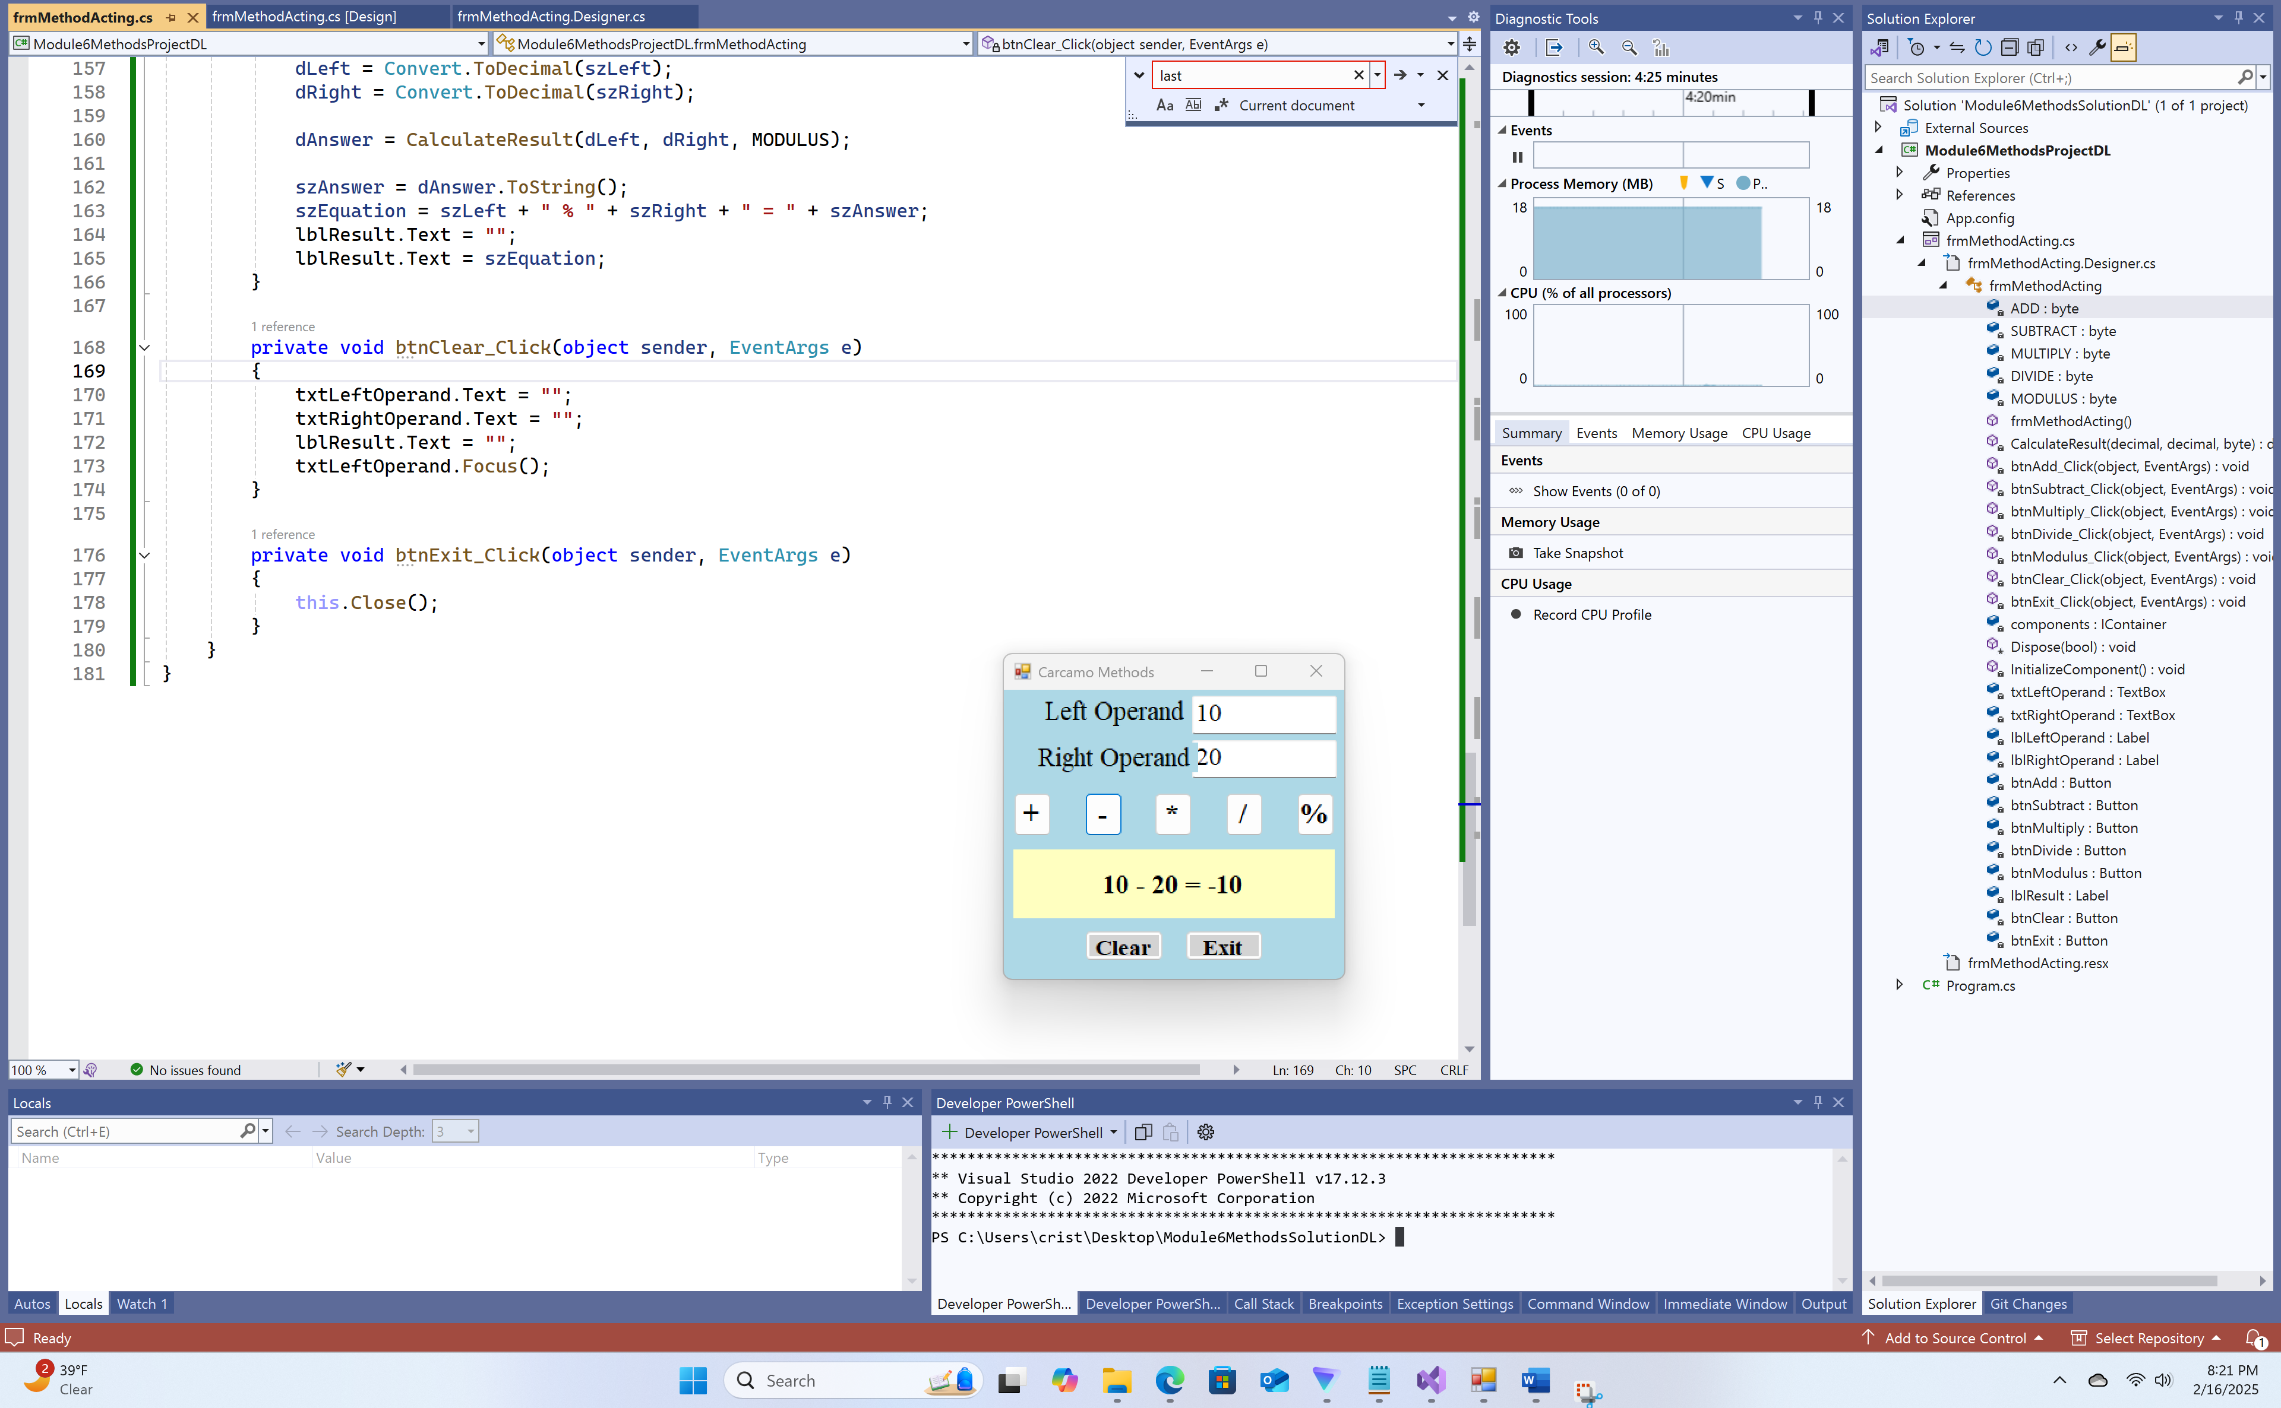

1. Multiply Operator

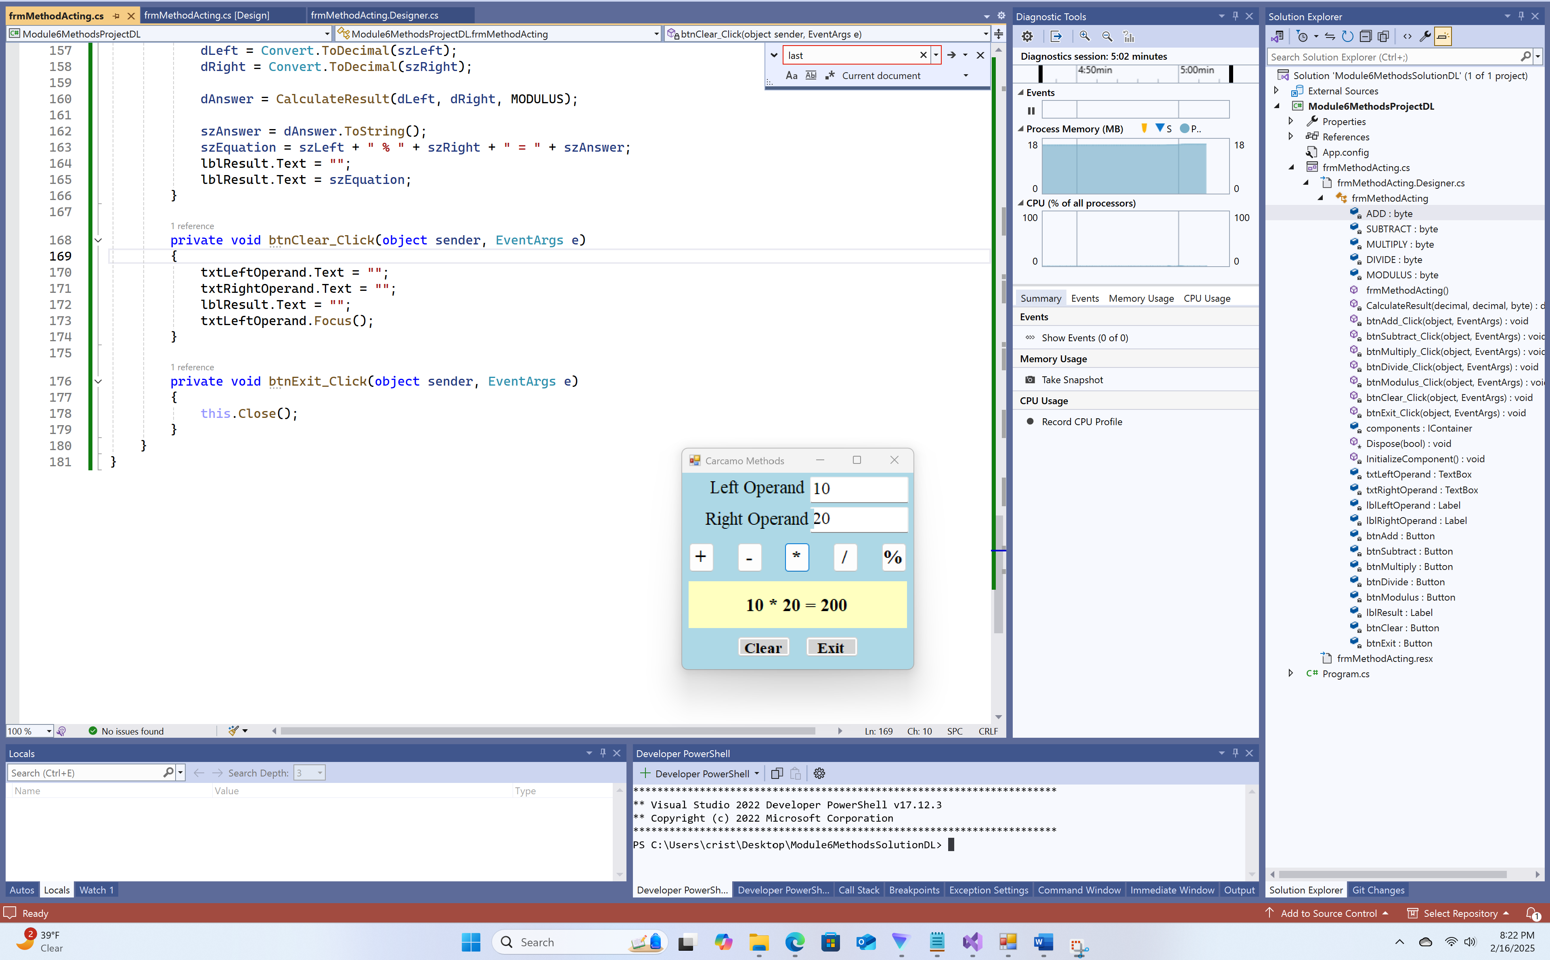

1. Divide Operator

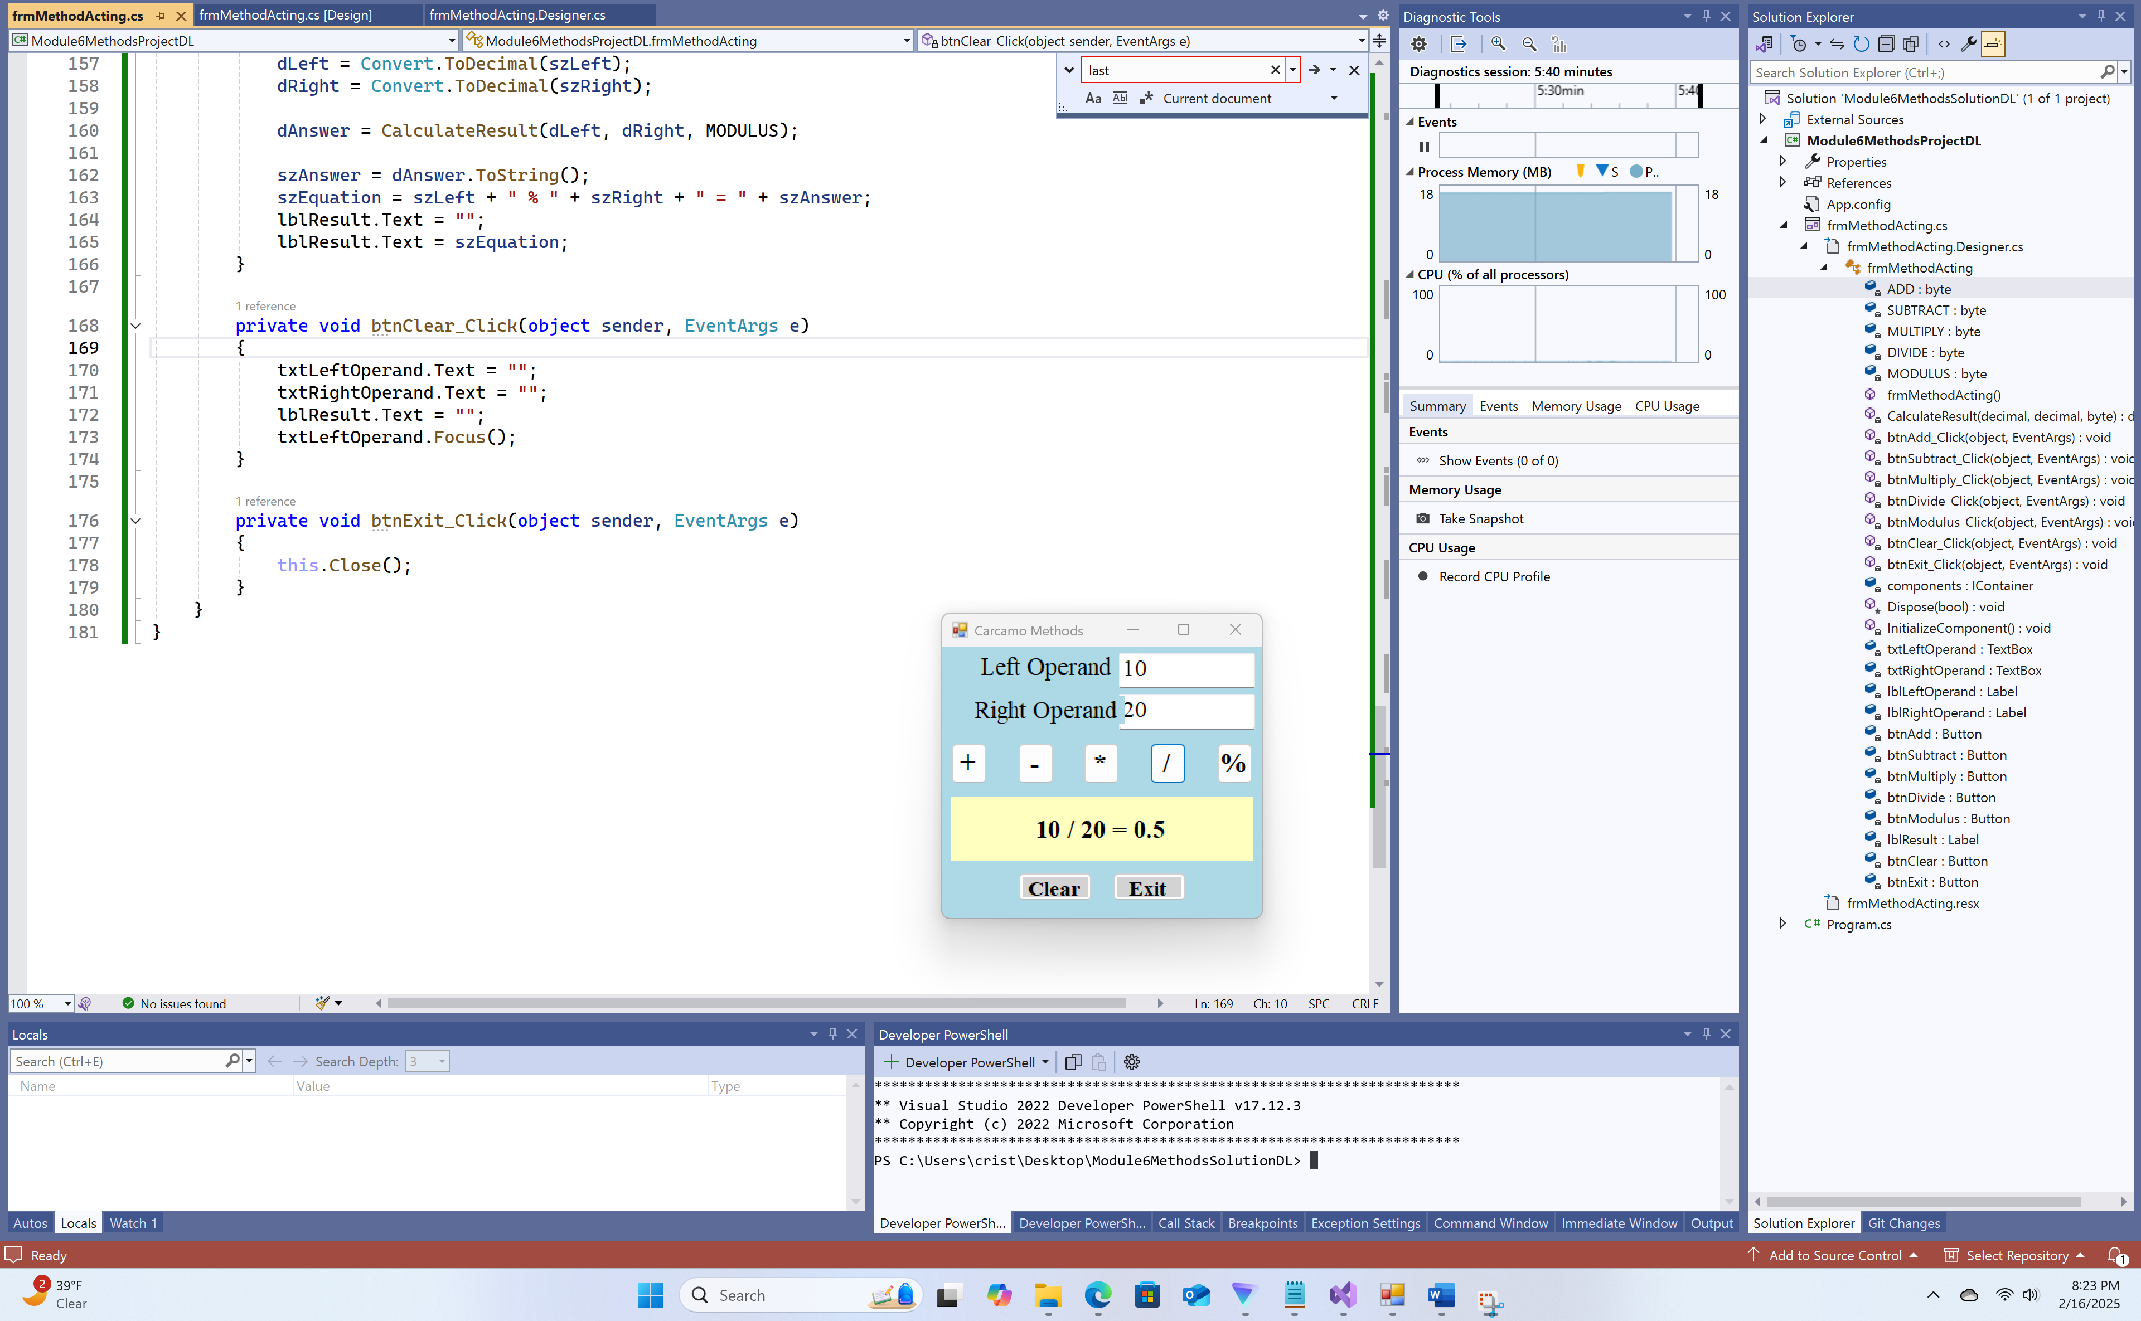

1. Modulus Operator

